**Lovely Professional University**



**A REPORT on the PROJECT**

**Design a Puzzle Game in which, various letters will be shown in a table and he/she can move horizontally, vertically or diagonally in order to make meaningful words.**

**For The Course**

**"INT 213"**

**Submitted by- Submitted to-**

**1.Satish Chauhan ISHAN KUMAR**

**Reg no. (11902149)**

**Roll number:30**

**2.Jatin Srivastava**

**Reg no. (11902181)**

**Roll number :- 22**

**3.GAURAV SARMA**

**Reg no. ( 11902152 )**

**Roll number:31**

1

ABSTRACT

The goal of this project was design a puzzle game in which, various letters will be shown in a table and he/she can move horizontally, vertically or diagonally in order to make meaningful words.

We use Jupyter notebook to make this project complete.

2

Acknowledgement

I take this opportunity to present my votes of thanks to allthose guidepost who really acted as lightening pillars to enlighten our way throughout this project that has led to successful and satisfactory completion of the study. We are really grateful to our teacher for providing us with an opportunity to undertake this project in this university and providing us with all the facilities. We are highly thankful to Ishan Kumar sir for his active support, valuable time and advice, wholehearted guidance, sincere cooperation and pain-taking involvement during the study and in completing the assignment of preparing the said project within the time stipulated.

Lastly, we are thankful to all those particularly the various friend who have been instrumental in creating proper online environment and including new and fresh innovative ideas for us during the project, their help, it would have been extremely difficult for us to prepare the project in a time bound framework. 3

TABLE OF CONTENTS

Title page

Cover page 1

Abstract 2

Acknowledgement 3

Table of Contents 4

Introduction 5-6

Python module 7

Project Contribution 8

Results 9

References 10 4

**Introduction**

**Project Title:** Design a Puzzle Game in which, various letters will be shown in a table and he/she can move horizontally, vertically or diagonally in order to make meaningful words.

## Project Description:

The minimum requirement of GUI as follows:

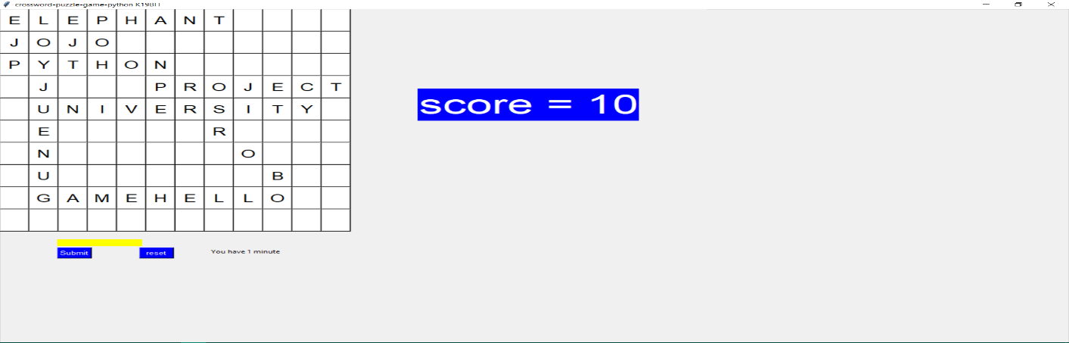

Use Above Written words in your puzzle game and size of metrics will be N*N.

In this project we are going to develop a puzzle game which is GUI based using python programming language.

**Word games** (also called word game puzzles) are spoken or board games often designed to test ability with language or to explore its properties.

Word games are generally used as a source of entertainment, but can additionally serve an educational purpose. Young children can enjoy playing games such as Hangman, while naturally developing important language skills like spelling. While Hangman is a seriously dark game, what we like to focus on is the development of the children. Researchers have found that adults who regularly solved crossword puzzles, which require familiarity with a

larger vocabulary, had better brain function later in life.

5

This project will be a dependent on user only, as there will be many English words will be hidden and user have to find them one by one.

## Scope of project

* The objective of the proposed project is to increase the thinking capability.
* The game having all the records which you perform in playing you can select easy, hard level according to your choice. You can make your own puzzle game and at any step you can go back to one step as well as you can see the solution of it.
* It is manually a very difficult job to perform and its need a lot of recalling, reminding and mathematical calculation. The game of word puzzle help to increase mental thinking, vision etc.

**Project Description**

This game will consist of table with many alphabets set in a random order and many English meaningful words will be hidden between them. User have to find them one by one as soon as possible. At the top game, name will be written there followed by, computer will ask the user to enter his/her name in the next step. Then we will have table of alphabets and background will be of beautiful solid colour. At the right side of table will have “Content of Words”, this section it will contains all the words those are hidden in that table. So that it will be easy for the user to search for a particular word. At the bottom we will have “OK” and “Reset” and “Exit” button. In this project we will take various function and keywords in order to make it look attractive and proper functioning without getting any error and as per requirement and maintain the basic requirement as per the topic and basic requirement given to us. 6

**PYTHON MODULE**

For making the word puzzle game we use various functions, input and python libraries but mainly weuse tkinter.

**Python GUI-Tkinter**:-Python offers multiple options for developing GUI (Graphical User Interface). Out of all the GUI methods, tkinter is most commonly used method. It is a standard Python interface to the Tk GUI toolkit shipped with Python. Python with tkinter outputs the fastest and easiest way to create the GUI applications. Creating a GUI using tkinter is an easy task.

**To create a tkinter:**

1.Importing the module-tkinter

2.Create the main window(container)

3.Add any number of widgets to the main window

4.Apply the event Trigger on the widgets.

**Button Function**

**OK Button:-**In OK button user have to press after searching all the words hidden in that table.

**Reset Button:-**In RESET button, if user wants to reset the whole game then he/she can press RESET button which will be on the bottom of that game in the right side of Ok button.

**Exit Button:-**If user wants to take exit from the game then user can click on EXIT Button to get out of the game any time.

**Table:-**Table will be of N * N order with many alphabets set in a random order and with 6-7 meaningful words hidden in it. 7

**PROJECT CONTRIBUTION**

**Materials**

**Jupyter notebook:-**We use anaconda Jupyter notebook to write the main code, and then we use Tkinter for GUI .

**Methods**

We have divide our work in three parts:

1.first make the interface of the game.

2.next make the OK, RESET Button

3.and then, Content inside table and working of game.

First one is done by Gaurav Sarma

Second one is done by Jatin Srivastava

And the third one is done by Satish Chauhan

8

**RESULT**

**1.**In this project we have learn how to use python for building gui project and how to implement it .

**2.** In this project, we will use random module to make a word guessing game. This game is for beginners learning to code in python and to give them a little brief about using strings, loops and conditional statements.

3.While working with my team we have learnt how to work with more and more people. And how to built Team spirit. 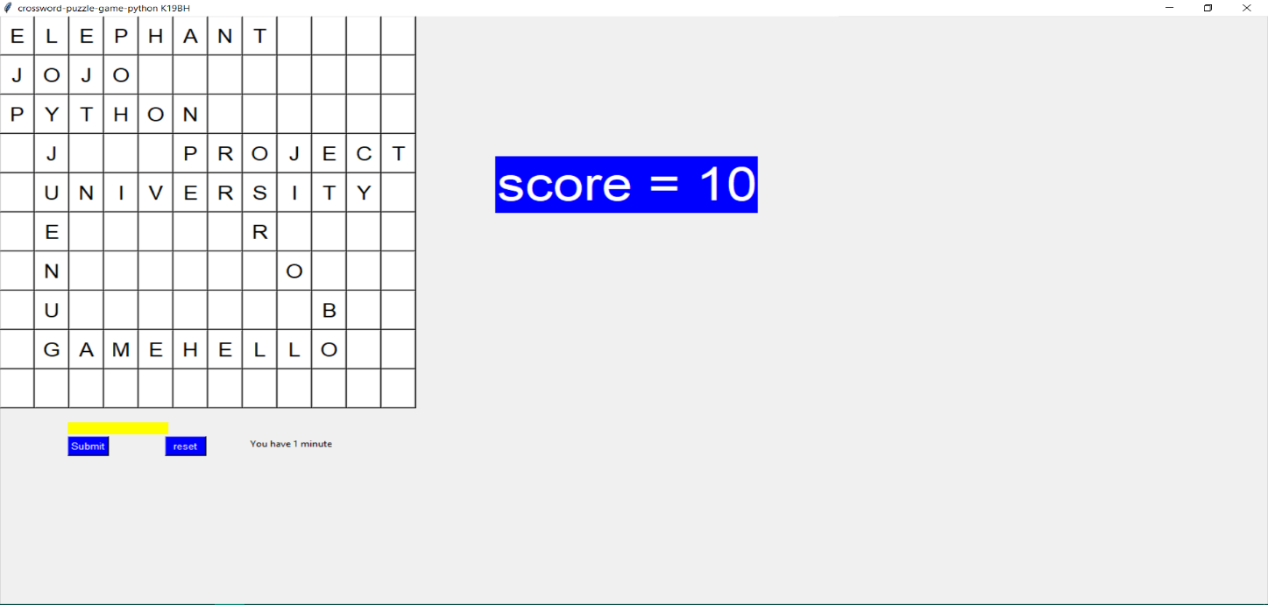 9 **References**

1.W3school :- <https://www.w3schools.in/python-tutorial/gui-programming/#A_Sample_Program_Using_Tkinter>

2.Python Documentation:- <https://docs.python.org/3/library/tkinter.html#tkinter-modules>

3.Geeksforgeeks:- <https://www.geeksforgeeks.org/python-simple-gui-calculator-using-tkinter/?ref=lbp>

4.tutorialspoint:- <https://www.tutorialspoint.com/python/python_gui_programming.htm>

-----------------------------------------Thank You---------------------------------- 10